- Cheapest Flights Within K Stops

Problem Statement:
There are n cities connected by some number of flights. You are given an array flights where flights[i] = [fromi, toi, pricei] indicates that there is a flight from city fromi to city toi with cost pricei.
You are also given three integers src, dst, and k, return the cheapest price from src to dst with at most k stops. If there is no such route, return -1.

Simplified Graph problem : Path of least weight with at most K+1 edges (or K+2 vertices)

Example 1:
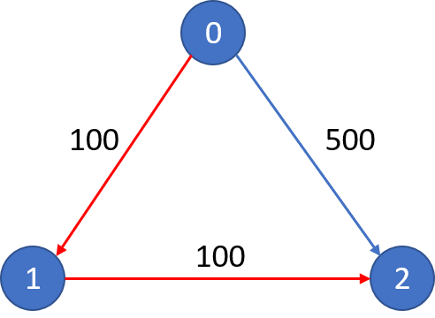
Input: n = 3, flights = [[0,1,100],[1,2,100],[0,2,500]], src = 0, dst = 2, k = 1Output: 200Explanation: The graph is shown.
The cheapest price from city 0 to city 2 with at most 1 stop costs 200, as marked red in the picture.
Input: n = 3, flights = [[0,1,100],[1,2,100],[0,2,500]], src = 0, dst = 2, k = 0Output: 500Explanation: The graph is shown.
The cheapest price from city 0 to city 2 with at most 0 stop costs 500, as marked blue in the picture.

Constraints:
1 <= n <= 100
0 <= flights.length <= (n * (n - 1) / 2)
flights[i].length == 3
0 <= fromi, toi < n
fromi != toi
1 <= pricei <= 104
There will not be any multiple flights between two cities.
0 <= src, dst, k < n
src != dst

Applicable Methods:
- Djikstra Algorithm O(V²)
- Floyd Warshall Algorithm O(V³)
- Bellman Ford Algorithm O(V³) (takes care of negative cycles, but there arent any)
- BFS (with Heaps )
- DFS ( with Pruning)
- DFS ( with Memoization)

- DFS with Pruning

Time complexity:
time depends on your sparsity of graph. For dense graph, for finding just 1 path, time is O(V+E) but for sparse graph you can find all paths in the same amortized time. For dense graph, for finding all possible paths, you will have O(V.(V+E)) which can go to V^3 because E=V^2 for dense graph. So, the time for this problem will range from O(N+E) to O(N.(N+E)).

